Lab 1. Portfolio

Aim: Create a personal portfolio webpage using HTML and CSS to showcase basic information and projects.

Output:

Home Page

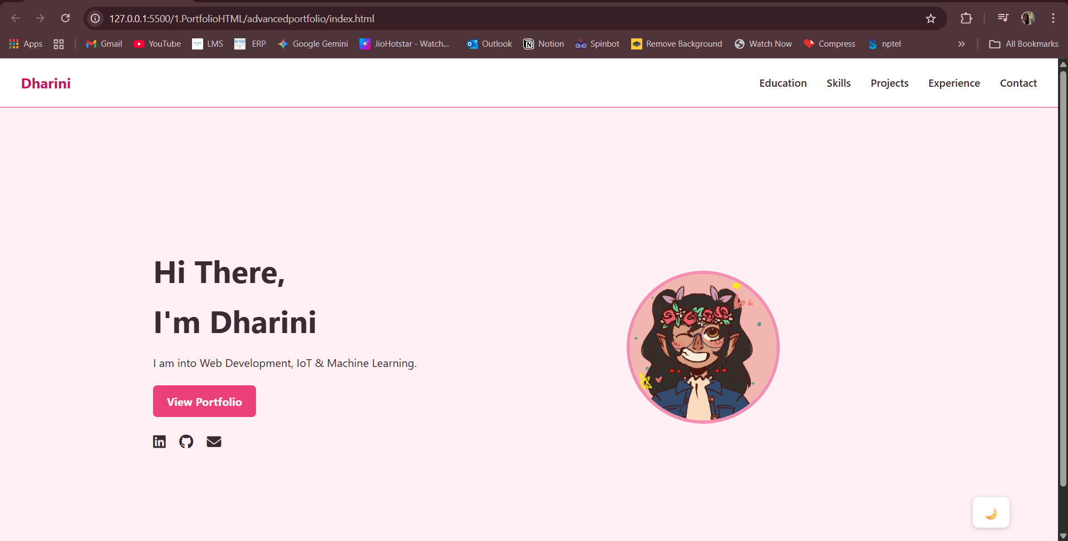

Education

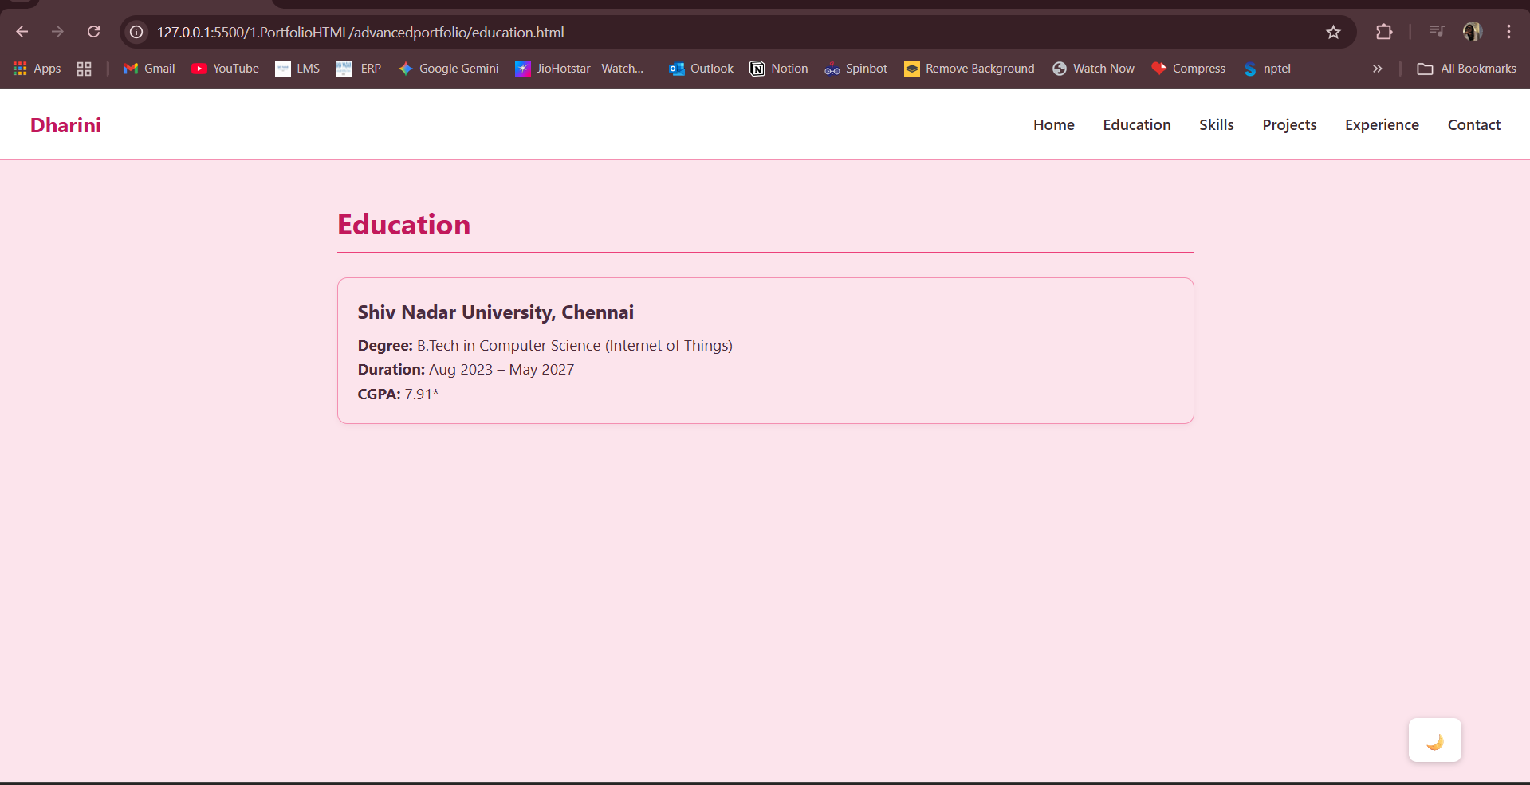

Skills

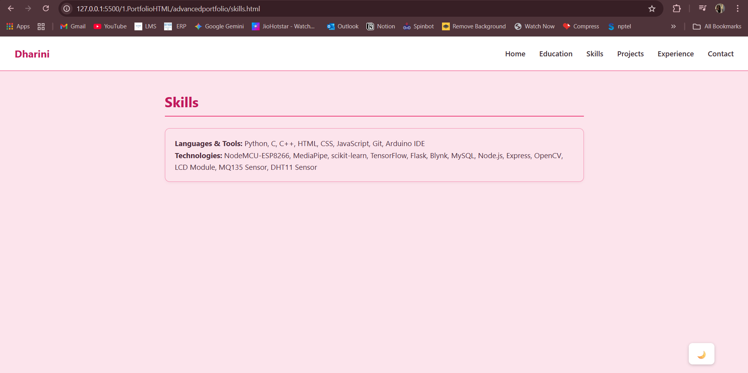

Projects

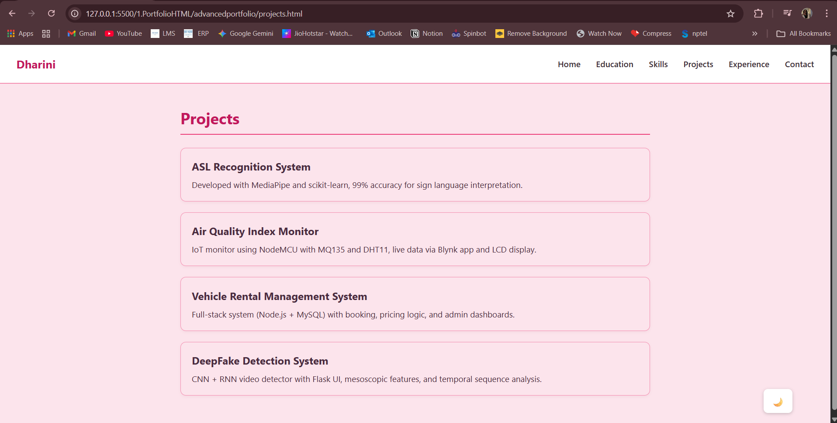

Experience

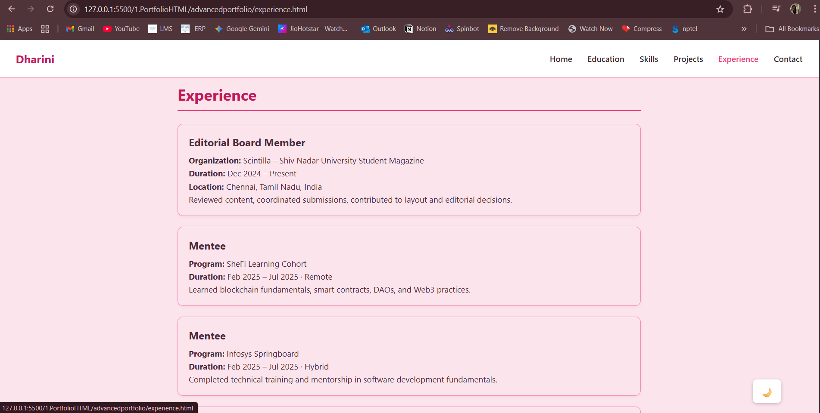

Contact

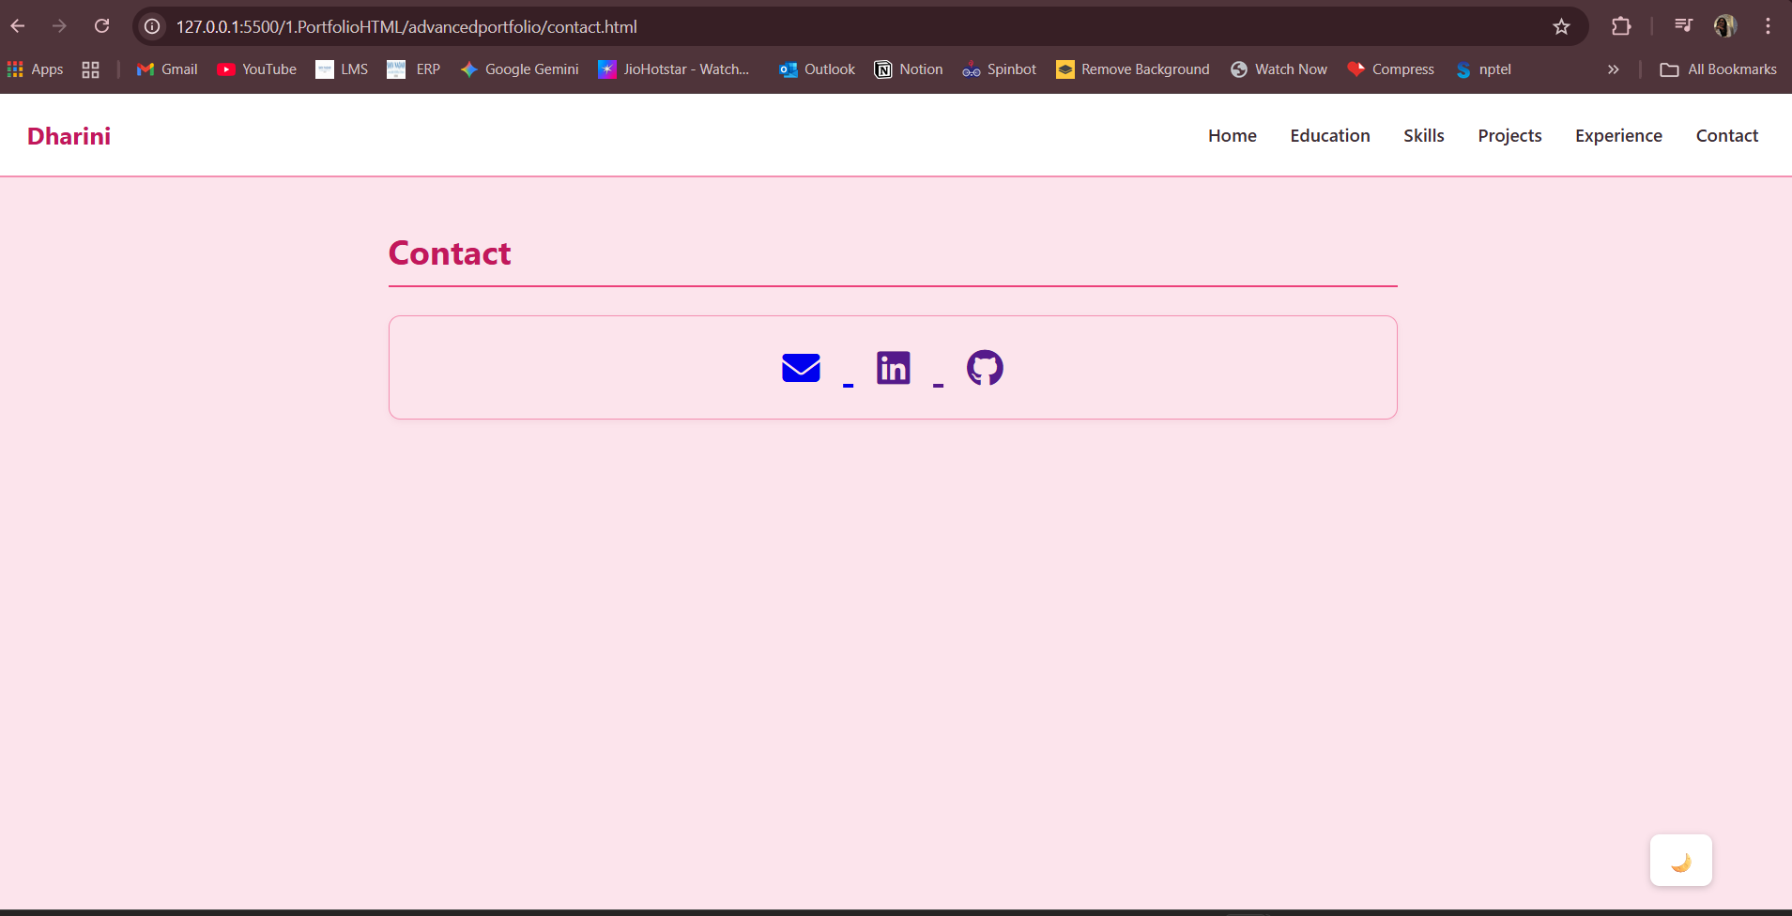

Home-Dark Mode

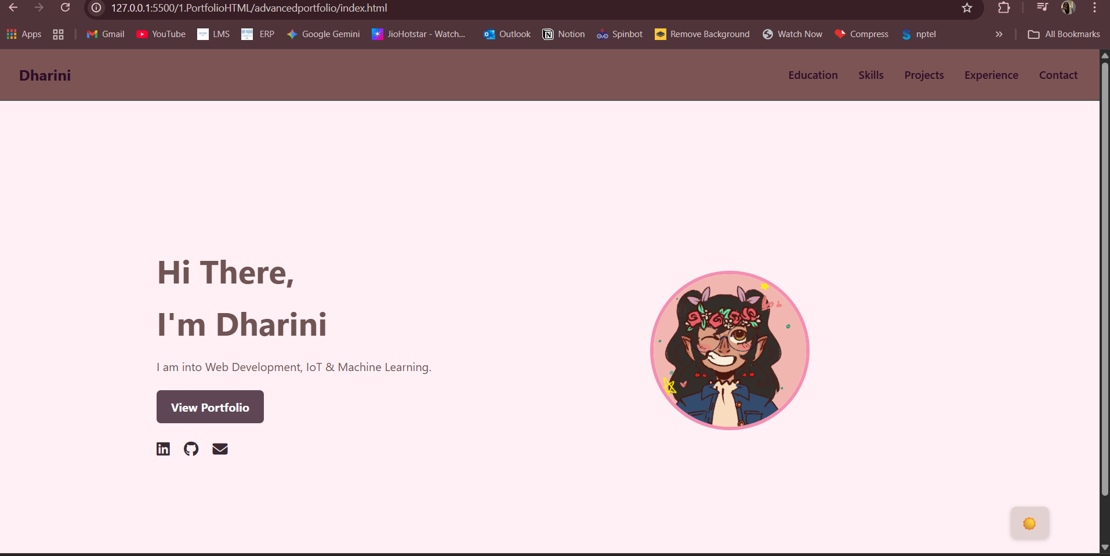

Lab 2. Weather App

Aim: Design a simple weather app interface using HTML and CSS to display weather information for a city.

Output:

Home

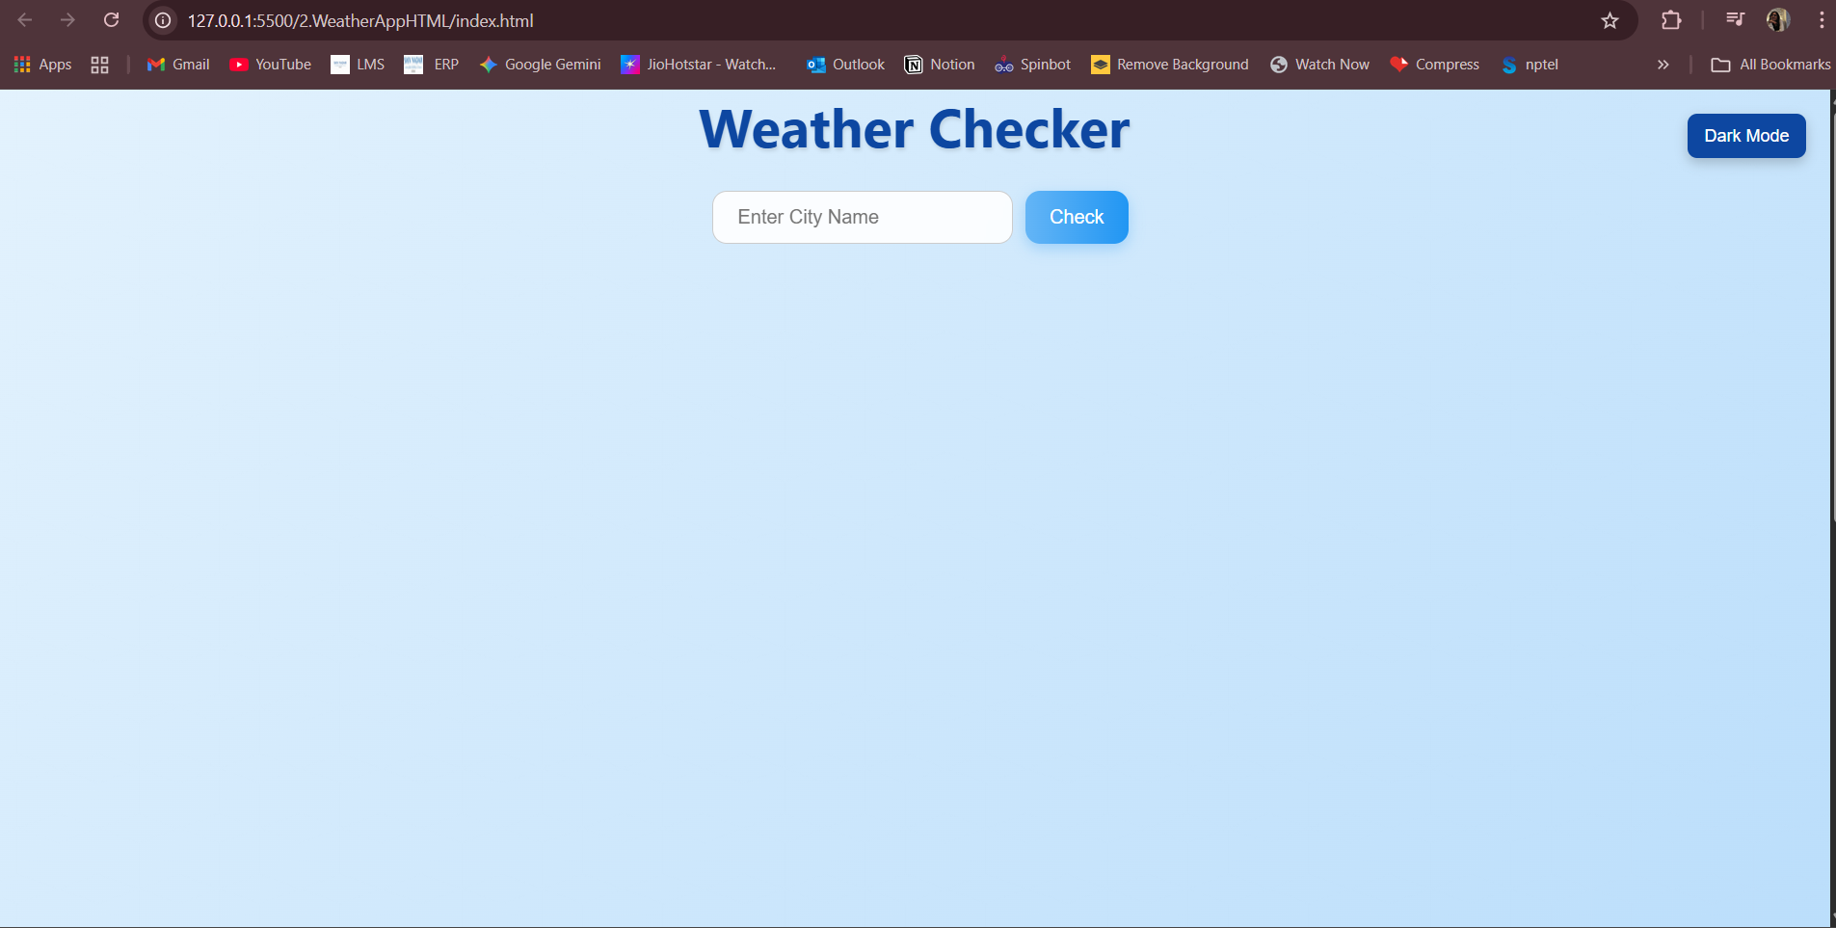

Input Result  
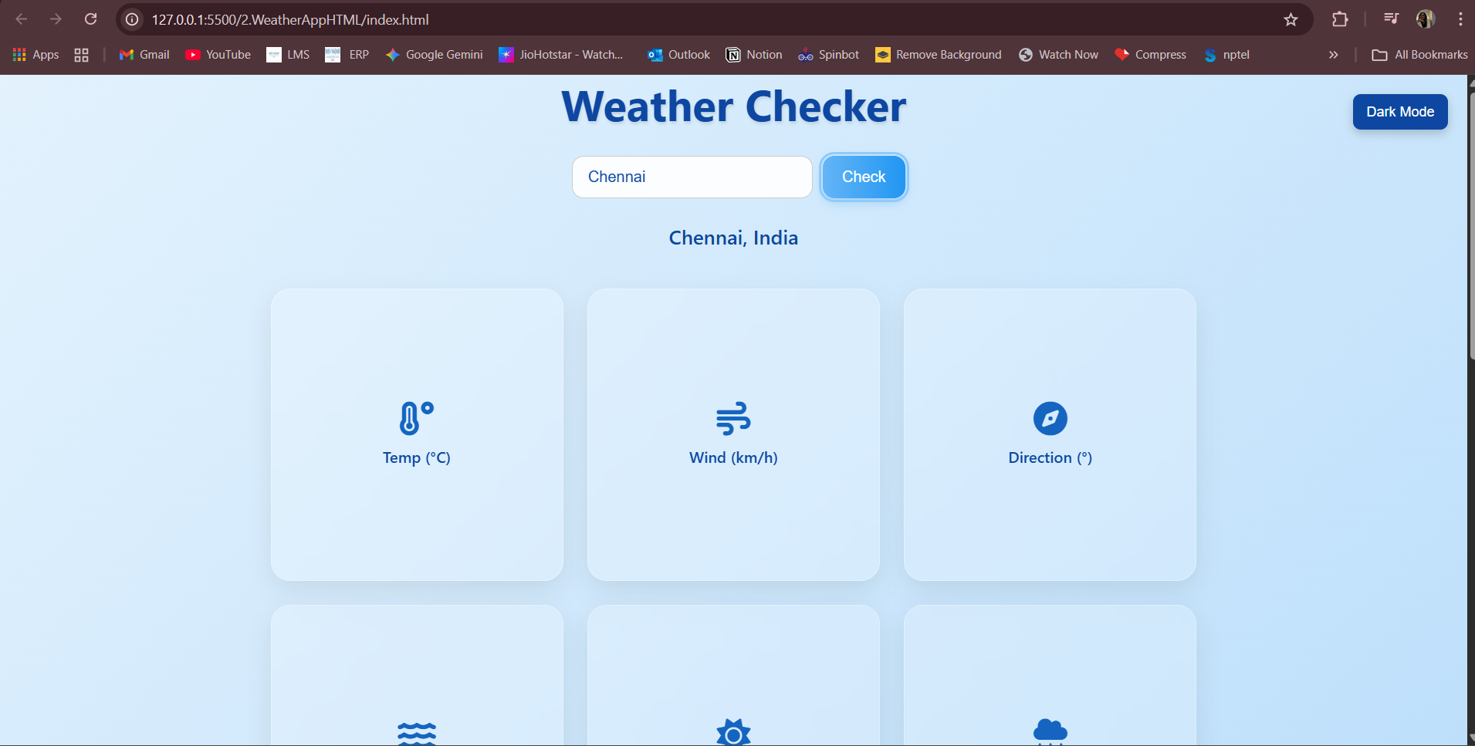

Value (on hover)

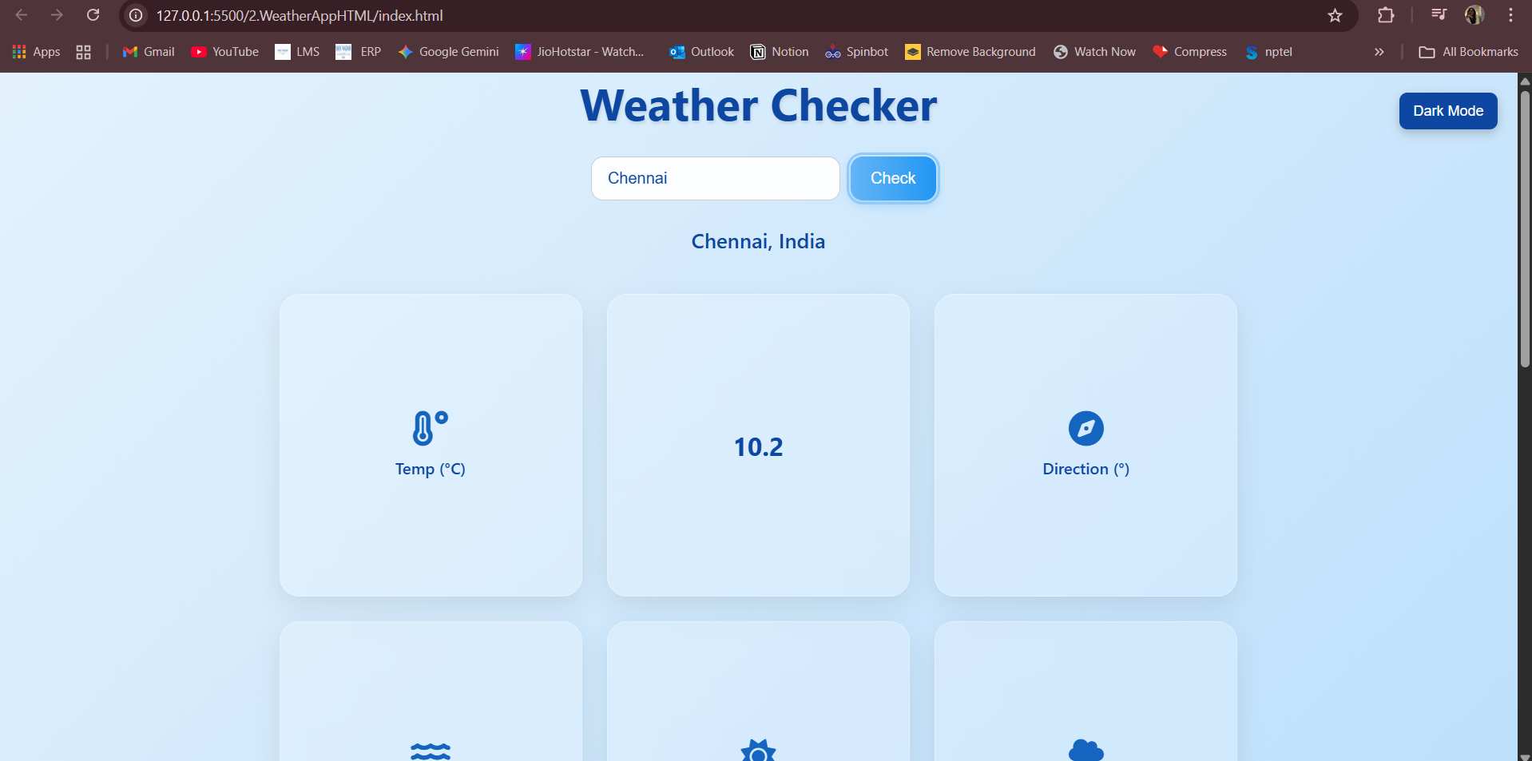

Dark Mode

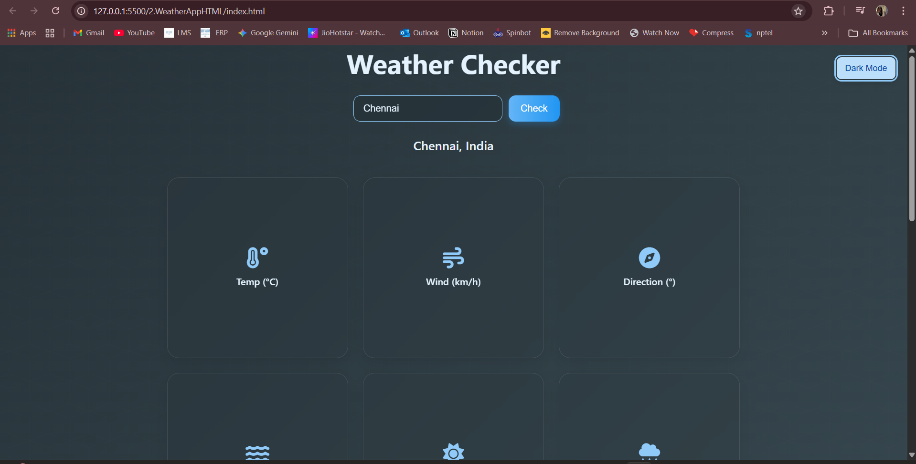

All Values

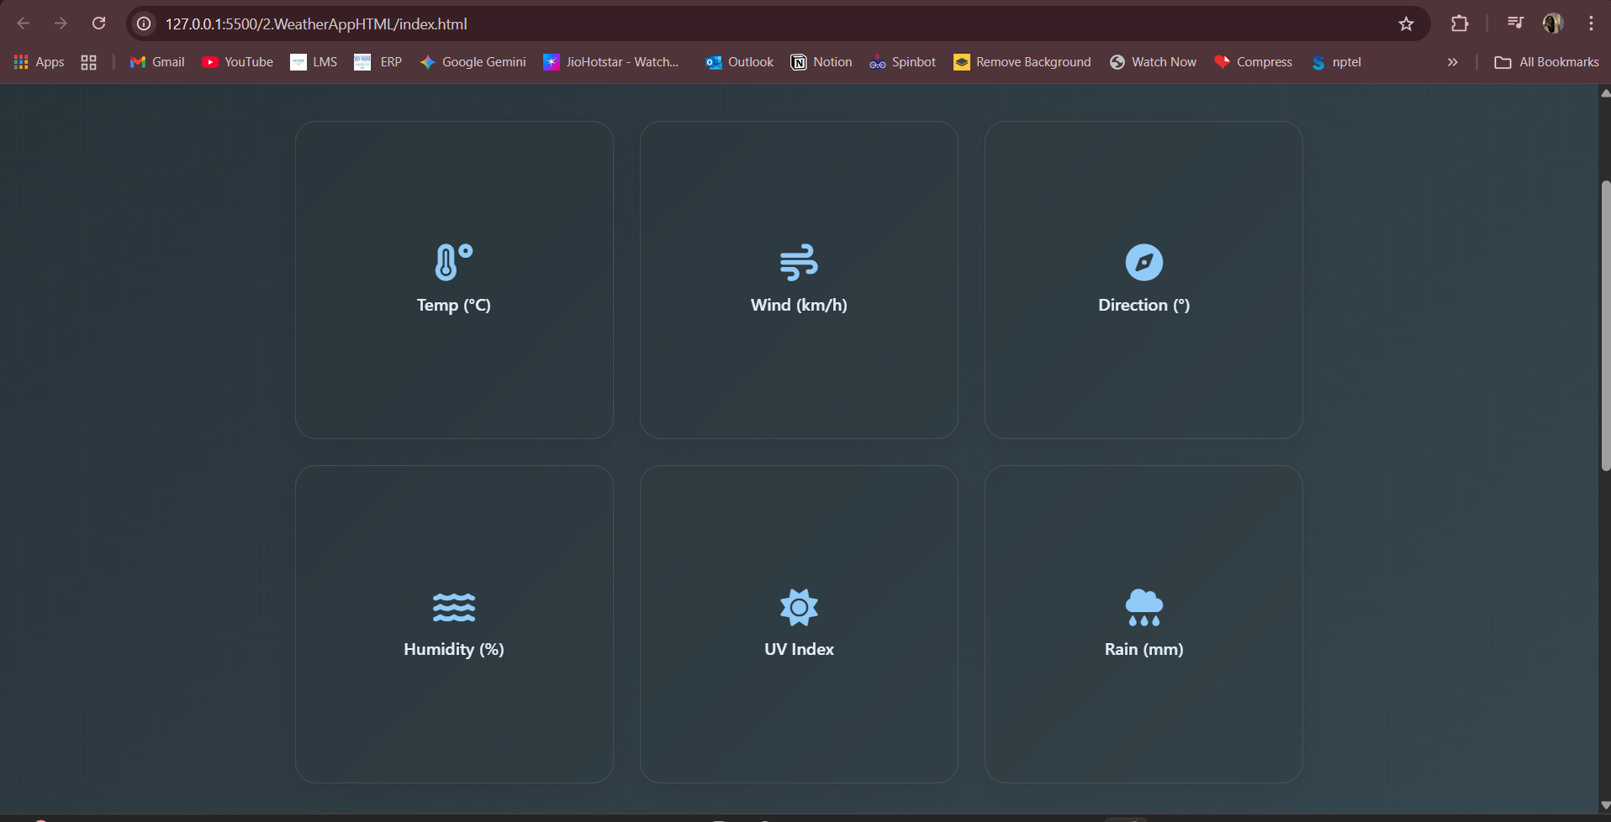

Lab 3. Event Registration Form

Aim: Develop an event registration form using HTML and CSS to collect participant details.

Output

Blank Form

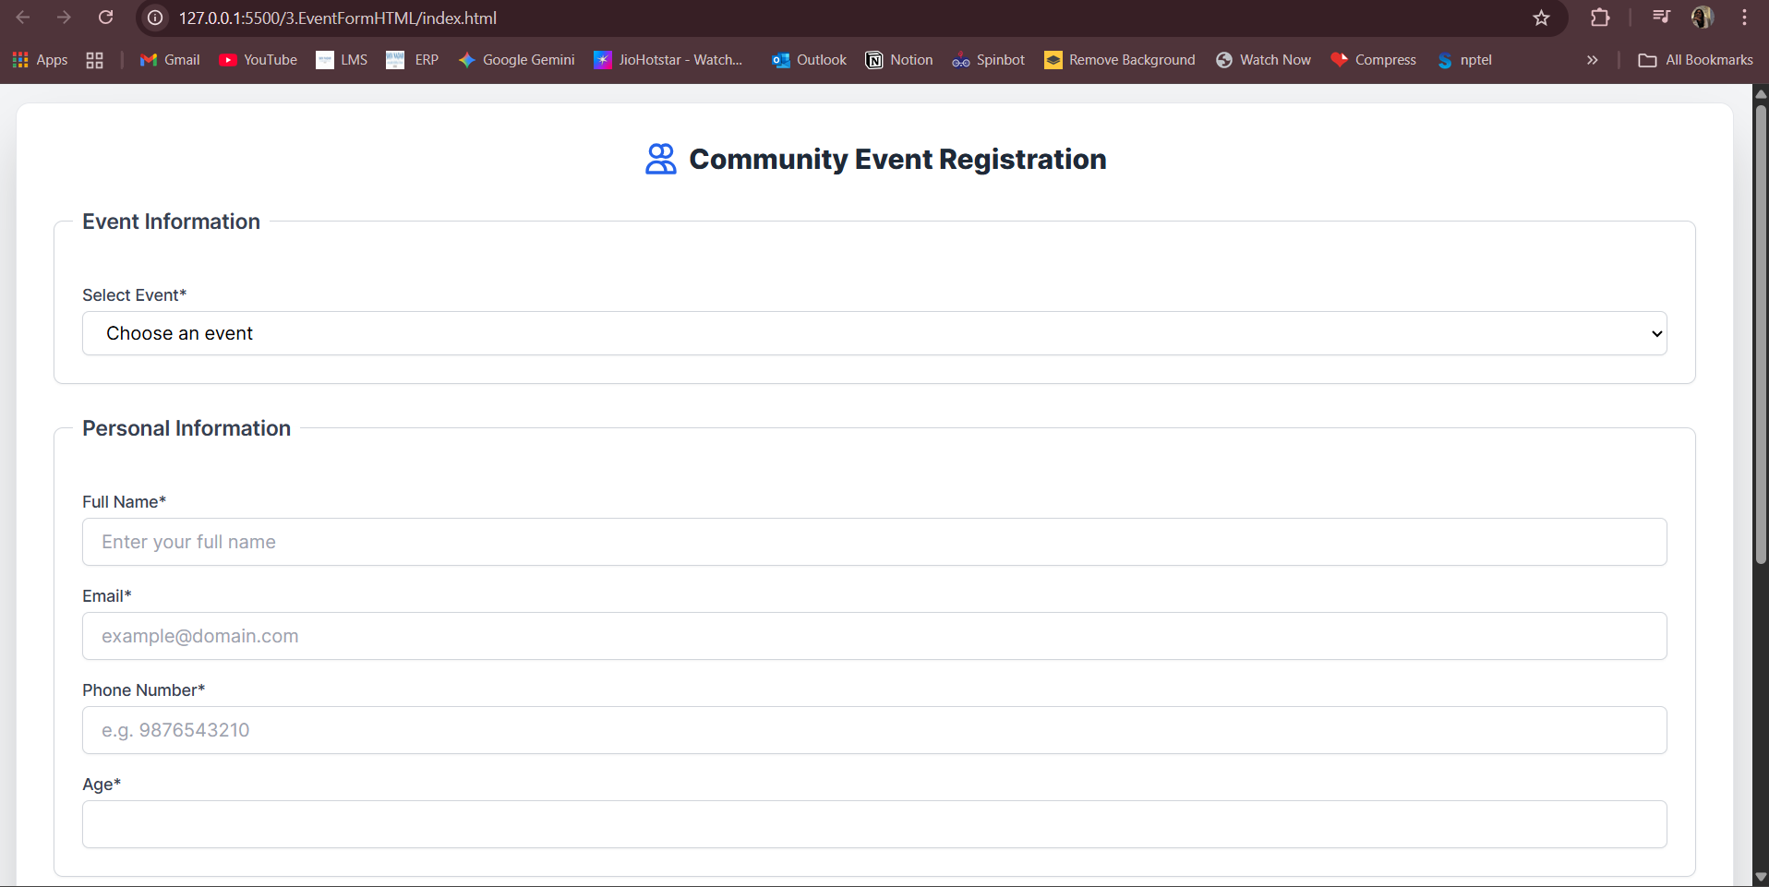

Drop down menu

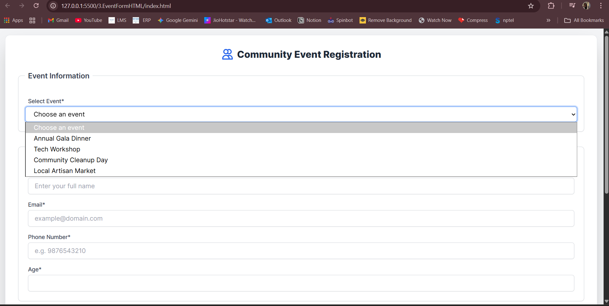

Error Checking for Input

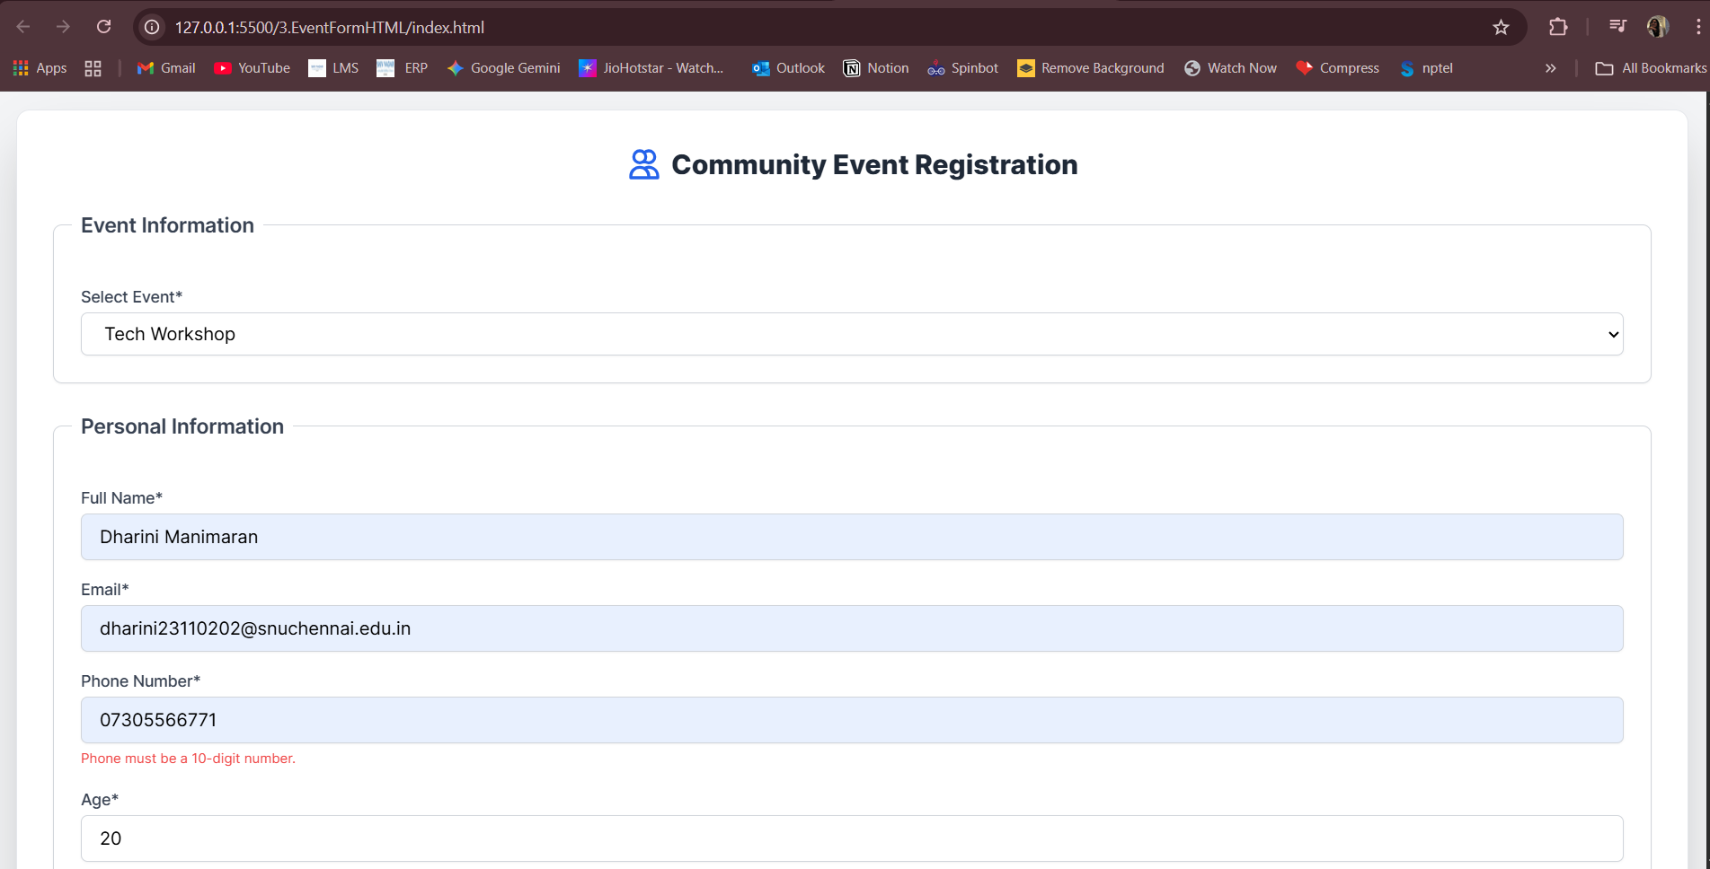

Thank you page

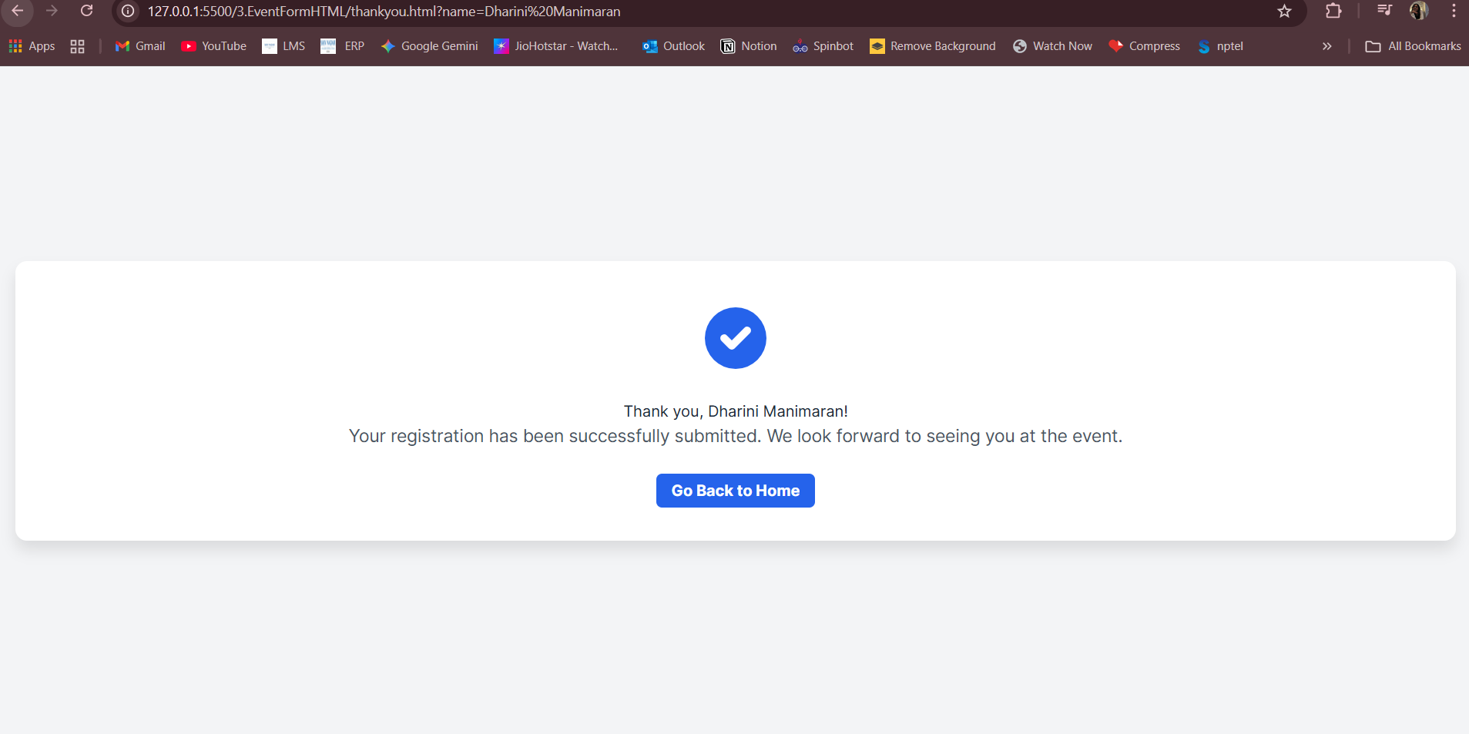

Lab 4. Portfolio – React

Aim: Build a portfolio website using React components to display personal details

Output

Home

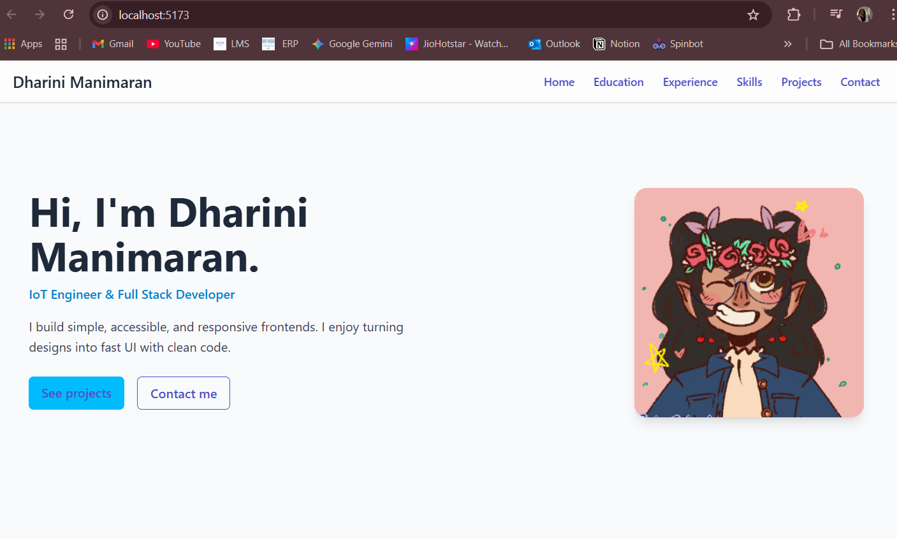

Education

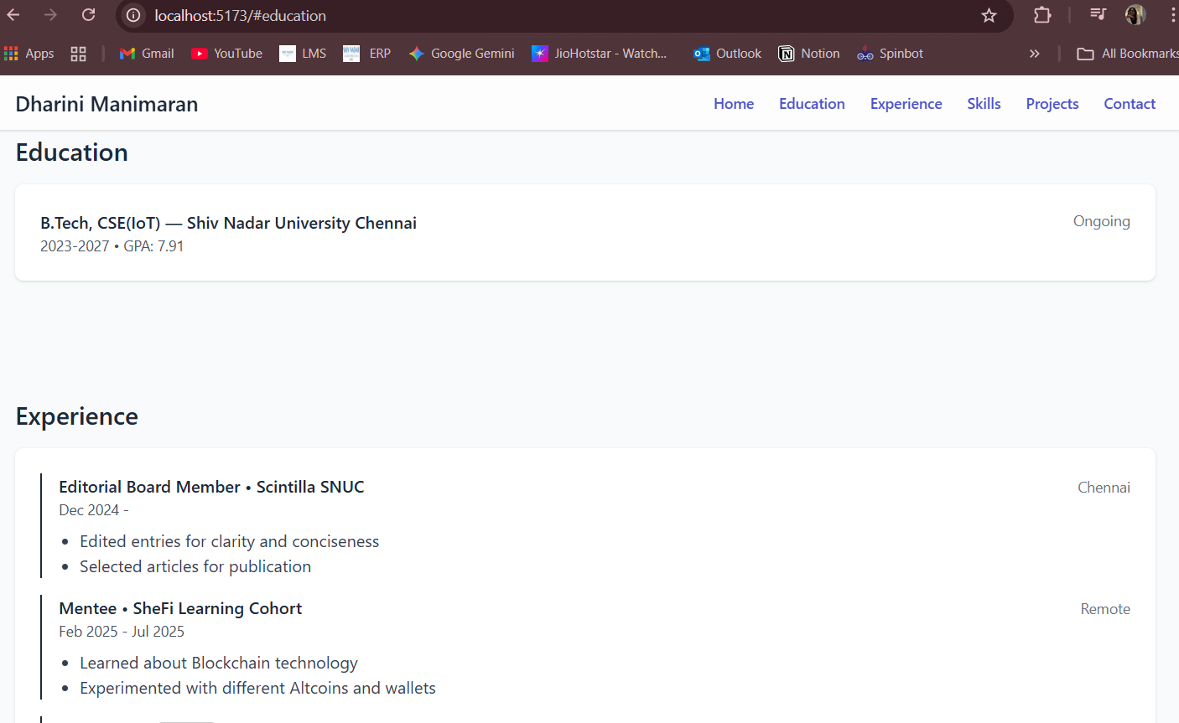

Experience

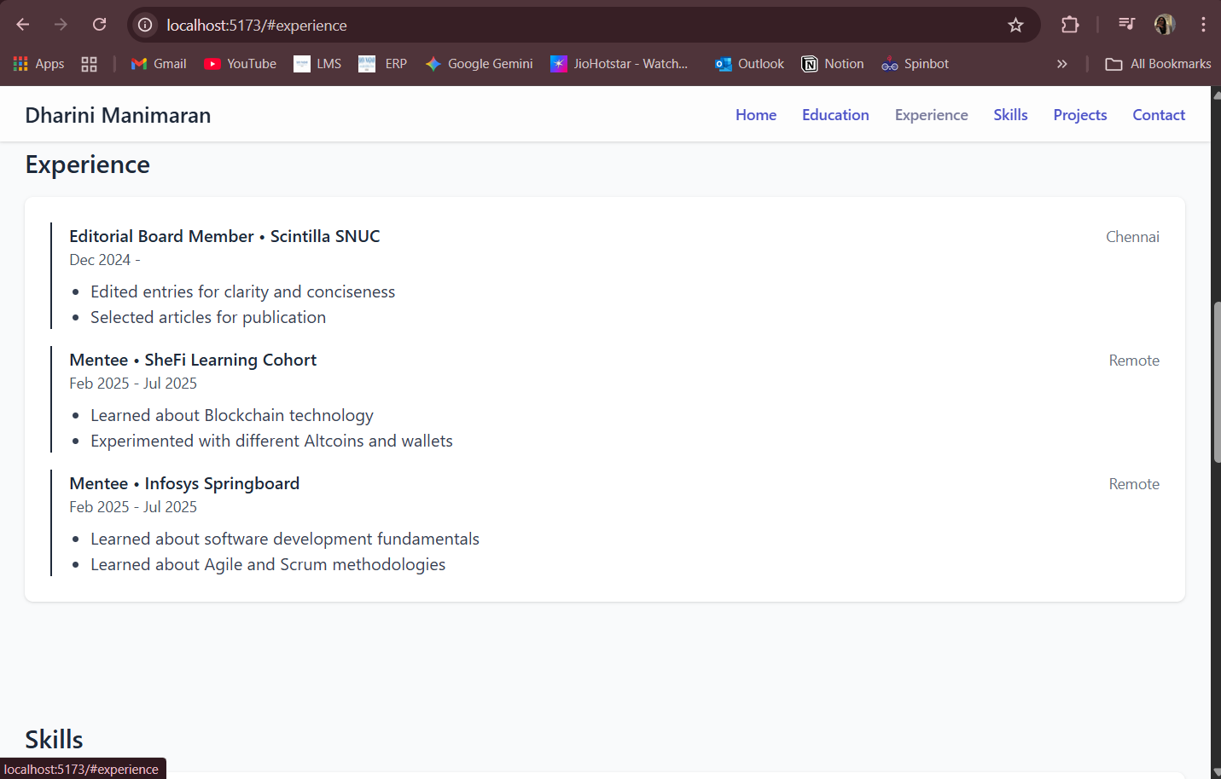

Skills

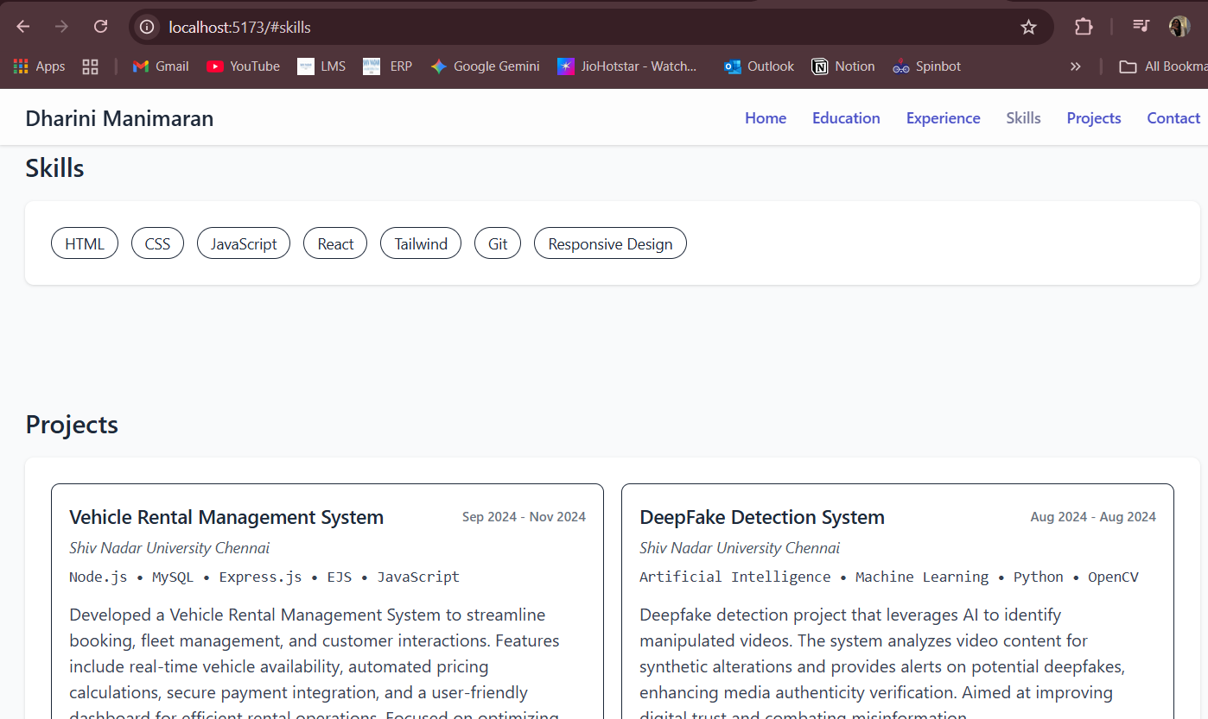

Projects

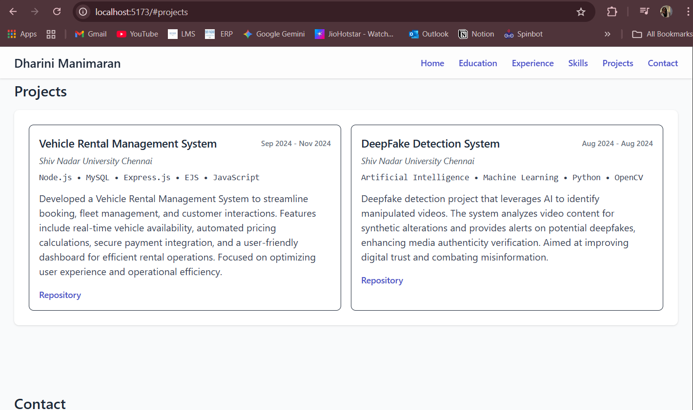

Contact

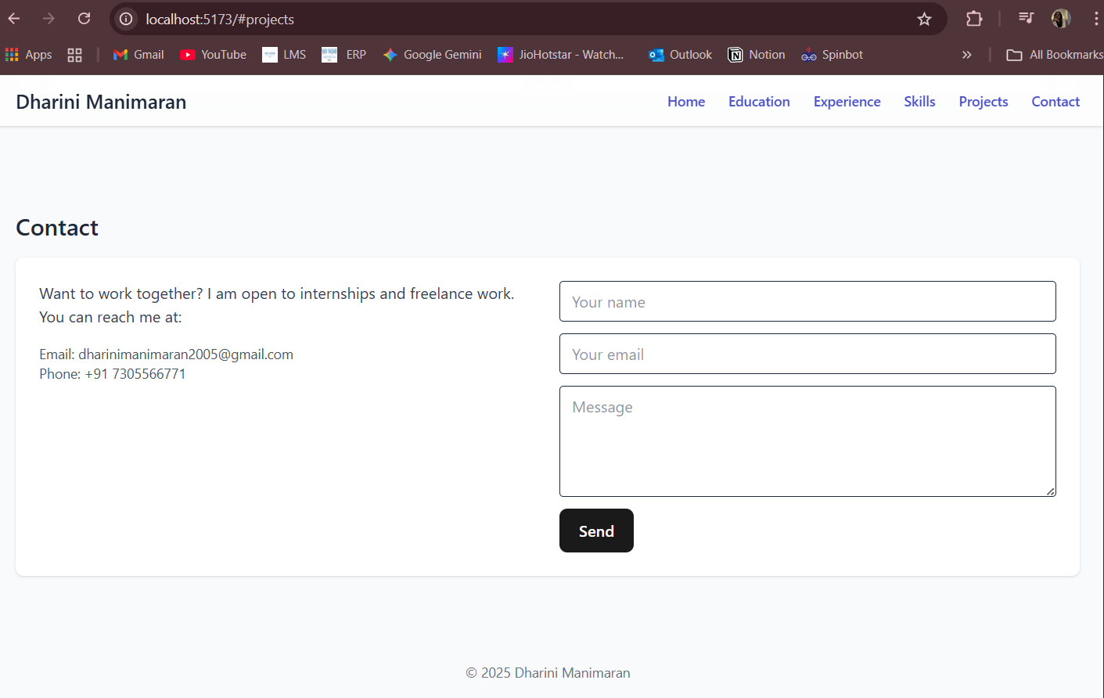

Lab 5. Weather – React

Aim: Create a weather app using React that displays weather information of a city.

Output

Home

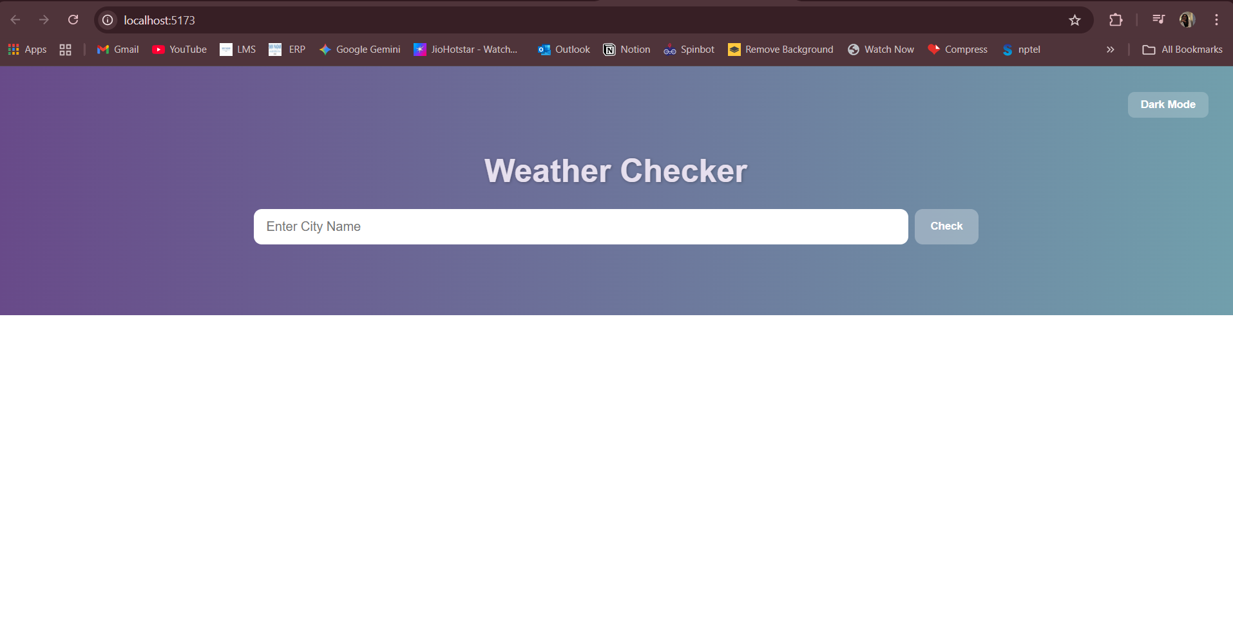

Values after Input

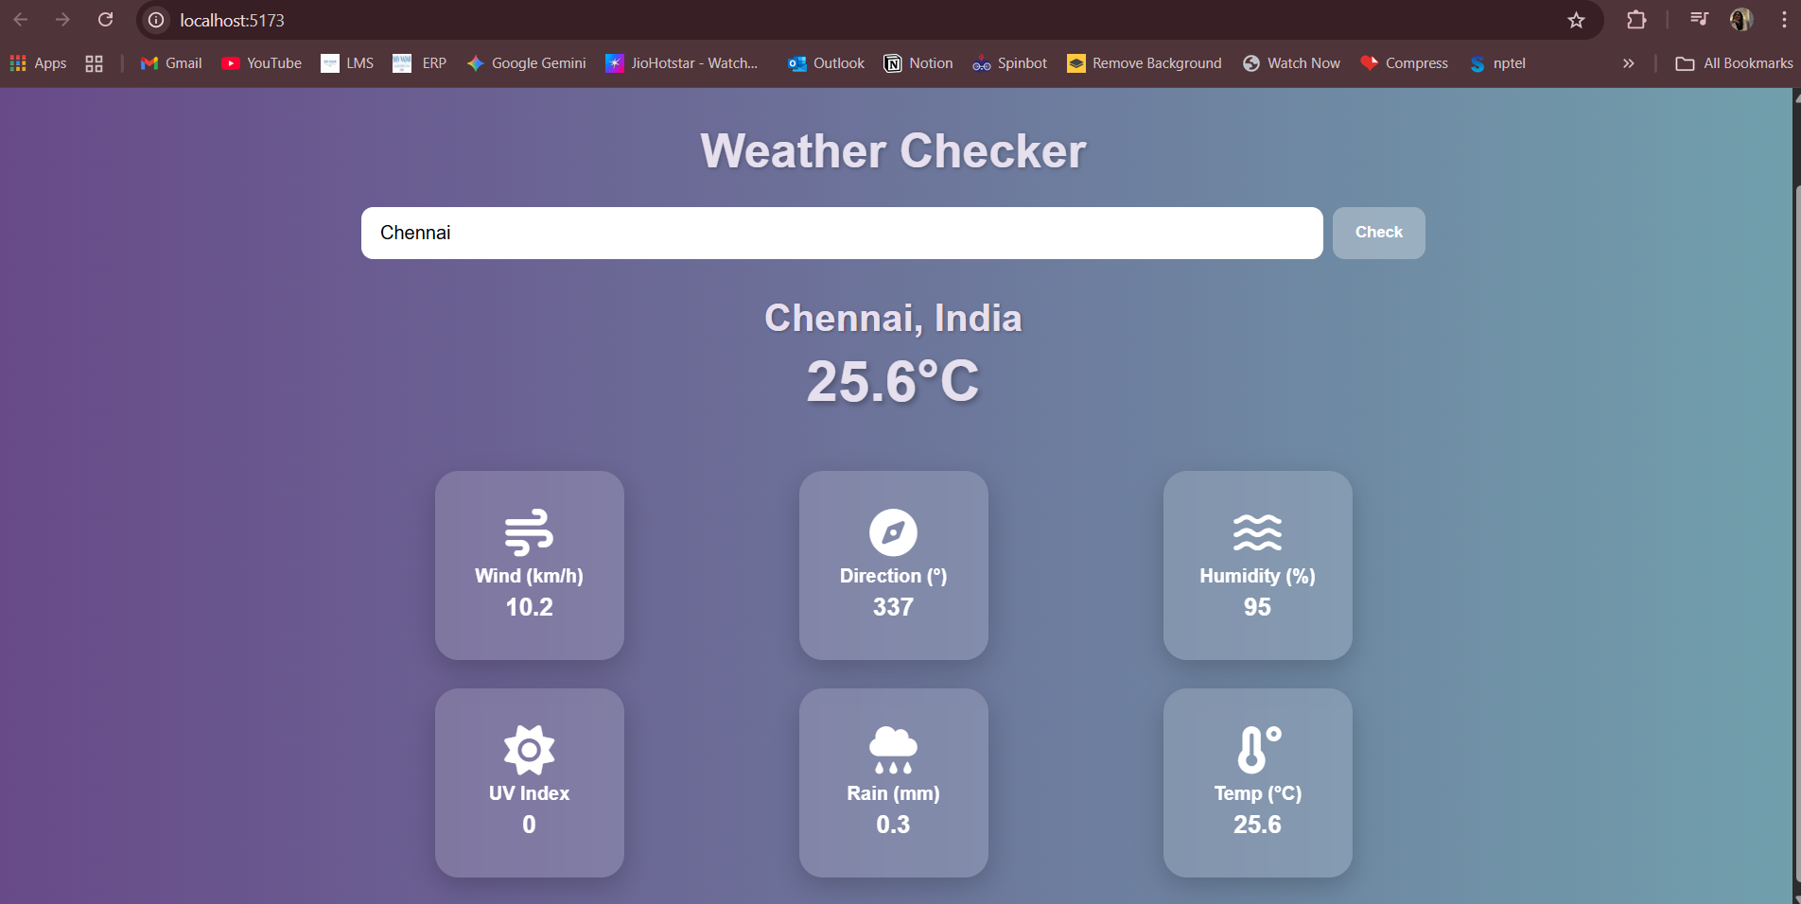

Dark Mode

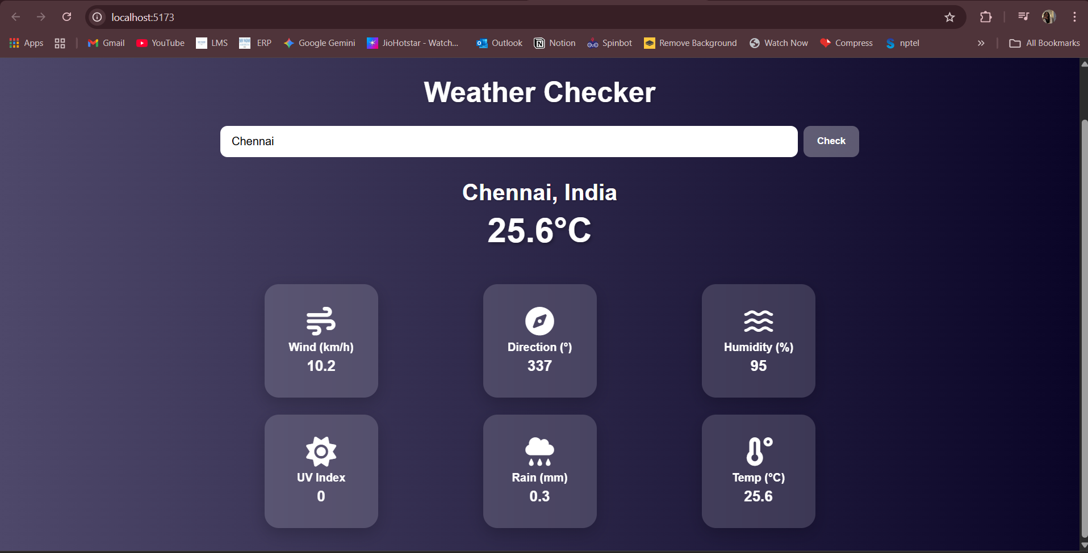

Lab 6. Event Registration Form

Aim: Develop an event registration form using React to collect participant details.

Output

Empty Form

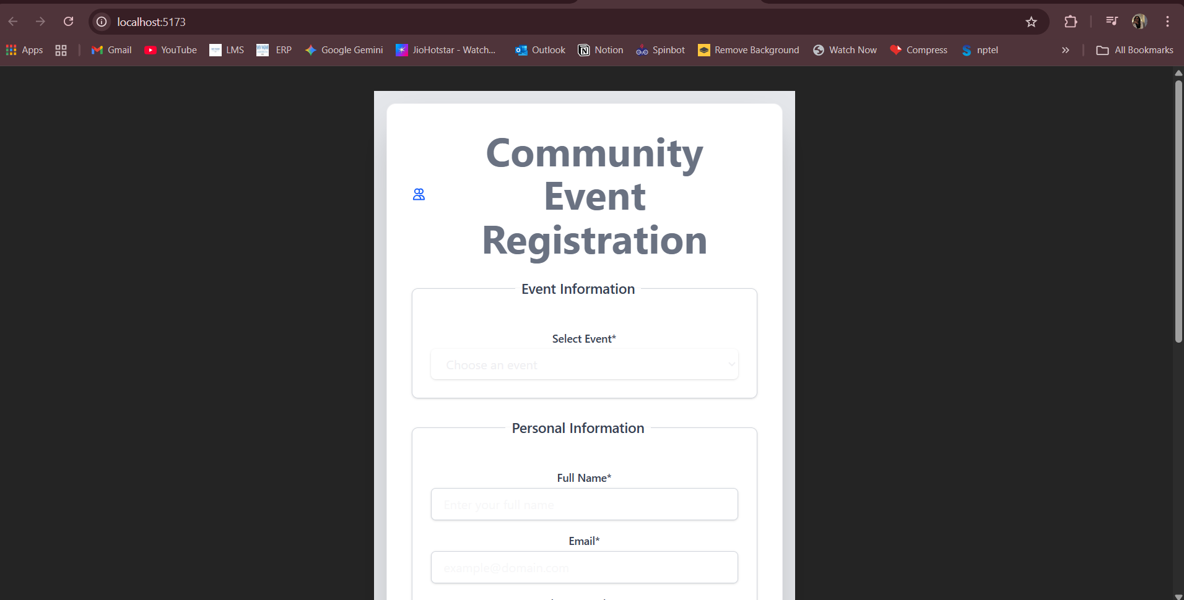

Drop down Menu

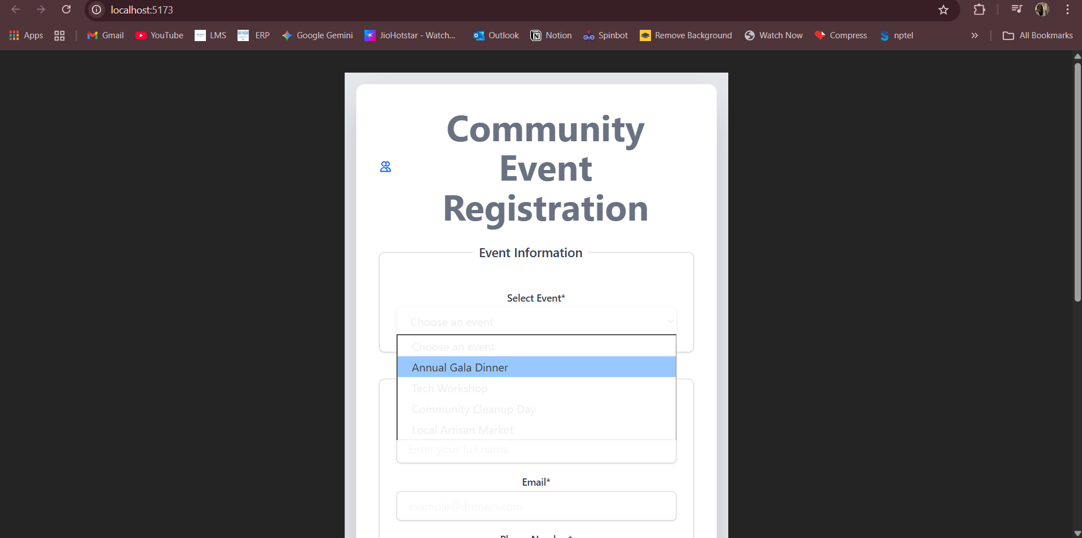

Error Checking of Input

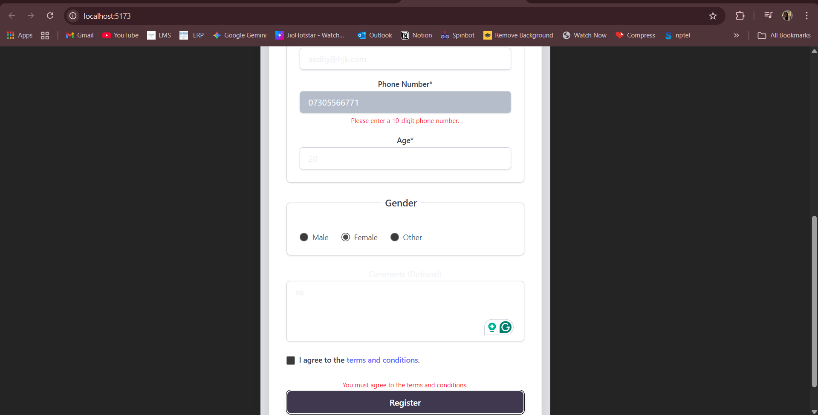

Lab 7. E-Commerce Platform (React)

Aim: Design a basic e-commerce platform using React with product listing and cart functionality.

Output

Home

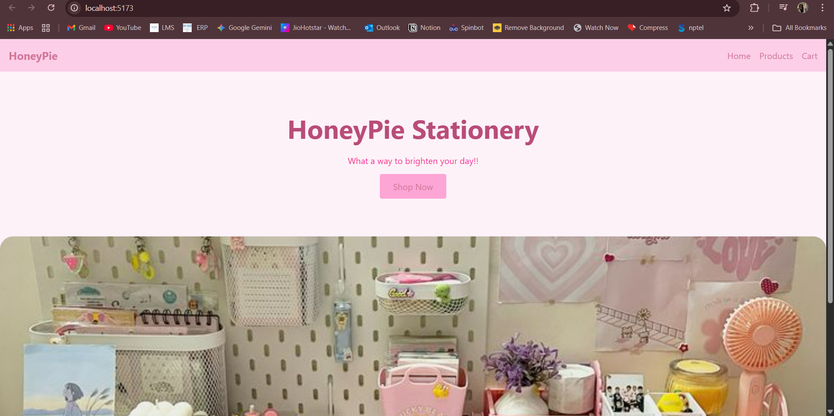

Products Display Page

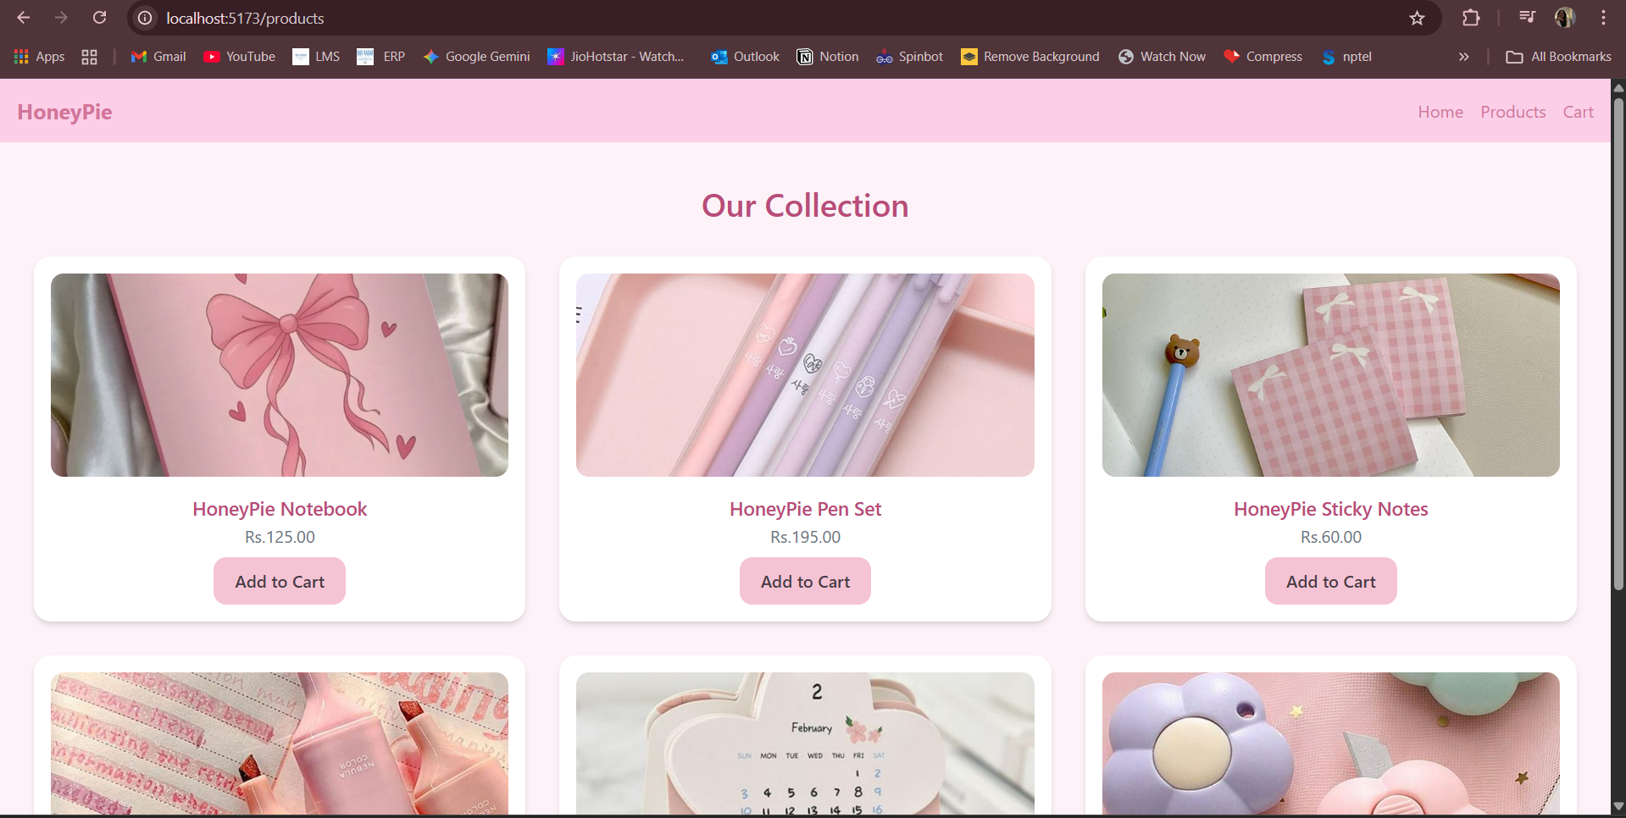

Product Details Page

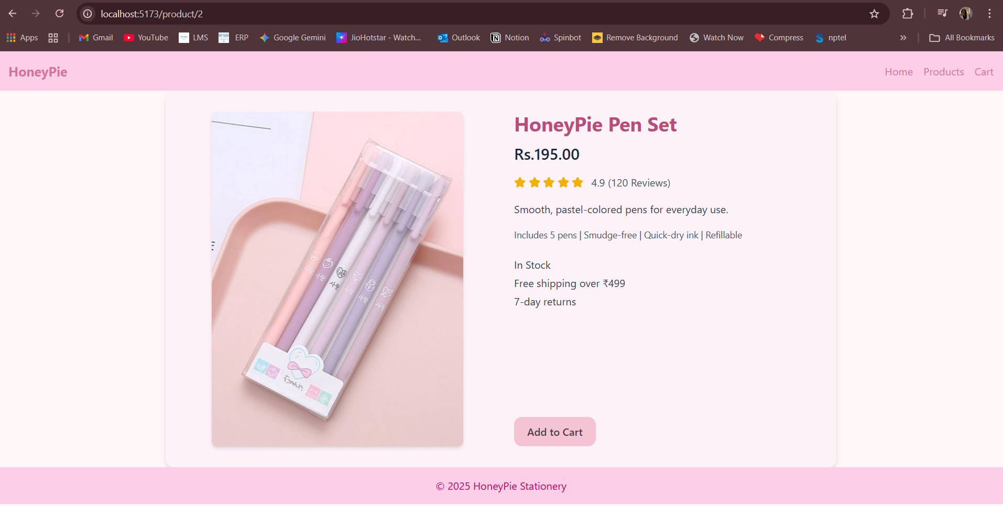

On pressing ‘Add To Cart’

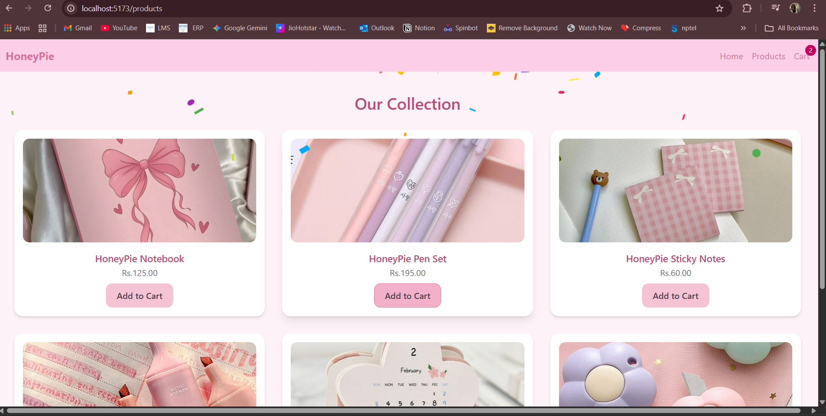

Cart

